

**Created by Kirubalan M, Yoganand U, Gowtham R,**

**Ajmal ahmed M**

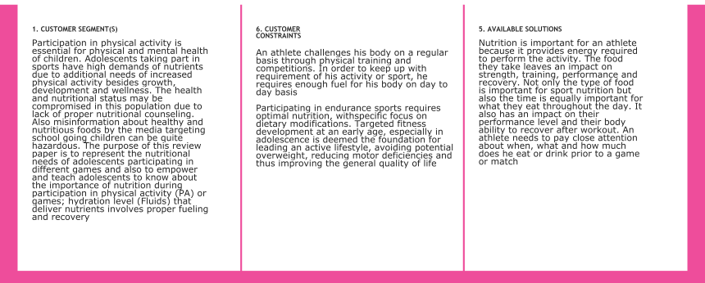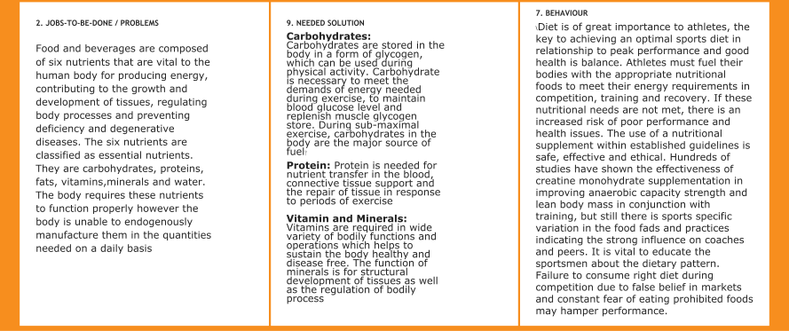

|  |  |  |  |
| --- | --- | --- | --- |
| **3 . TRIGGER**  Trigger foods are those that when eaten make you crave and possibly eat more. These foods are generally eaten out of habit, not necessarily hunger. Your trigger food(s) is/(are) something you probably feel addicted to and is likely high-calorie, processed and filled with non-nutritional carbs.  When you eliminate a trigger food from your diet, the craving you feel will become weaker and weaker within a week or two. Use the ideas below to replace common trigger foods with healthier, whole food options.  Trigger Food #1: Candy  Trigger Food #2: Salty Snacks  Trigger Food #3: Sweet Drinks Trigger Food #4: Fried Foods  Trigger Food #5: Baked Treats | **8 . CHANGES**  **The information below outlines four stages you may go through when changing your health habits or behavior. You will also find tips to help you improve your eating, physical activity habits, and overall health. The four stages of changing a health behavior are**   * **contemplation** * **preparation** * **action** * **maintenance**   **5 way of changes need to live healthy lifestyle**   1. Measure and Watch Your Weight. ... 2. Limit Unhealthy Foods and Eat Healthy Meals. ... 3. Take Multivitamin Supplements. ... 4. Drink Water and Stay Hydrated, and Limit Sugared Beverages. ... 5. Exercise Regularly and Be   Physically Active | **10 . YOUR SOLUTION**  As you settle into an active lifestyle, you’ll probably discover which foods give you the most energy and which have negative effects. The key is learning to listen to your body and balancing what feels right with what’s good for you   * Aim to make breakfast a part of your routine. * Choose complex carbohydrates,   lean protein sources, healthy fats, and a wide variety of fruits and veggies.   * Stock your fridge and gym bag with healthy workout snacks. * The right balance of carbohydrates, protein, and other nutrients can help fuel your exercise routine. * **Healthy options include:** * **nuts** * **seeds** * **avocados** * **olives** * **oils, such as olive oil** | 4 . EMOTIONS  Can healthy food actually make you  happy? **Yes, according to researchers, healthy eating, particularly fruits and vegetables, whole grains, and quality sources of protein can make you happy**.  When you stick to a diet of healthy food, you're setting yourself up for **fewer mood fluctuations, an overall happier outlook and an improved ability to focus**, Dr. Cora says. Studies have even found that healthy diets can help with symptoms of depression and anxiety.  **Nutrients such as folate, vitamin B6 and choline are necessary to synthesize certain brain chemicals, called neurotransmitters, that**  **regulate mood and memory**. An imbalance of neurotransmitters is often associated with mood-related conditions like anxiety and depression |